**SENIOR THREE**

**GEOGRAPHY**

**PAPER 1**

**TIME: 2:45 HOURS**

**ST JOHN’S HIGH SCHOOL KAWEMPE**

**S3 GEOGRAPHY**

**Paper 1**

**2 hours 45 minutes**

**INSTRUCTIONS TO CANDIDATES:**

This paper consists of two sections; A and B.

It has six examination items.

Section A has two compulsory items.

Section B has two parts; I and II.

Answer one item from each part.

Answer four examination items in all.

You may use diagrams where applicable to illustrate your answers.

Any additional item(s) answered will not be scored.

All answers must be written in the answer booklet(s) provided

**SECTION A:**

**Map and Photograph Skills**

**Answer all items in this section.**

**Item 1: Map Skills**

**Item 1: map skills**

The residents of lukaya living south of northing 90 engage in different activities to earn a living. Mary, a university student who specialized in aquaculture decided to conduct her internship from this area. She was mostly interested in guiding the local residents on how best they could handle the fishing activity and at the same time conserve the environment.

**Support material: map of Lukaya**

**Task:**

1. Mary is interested in knowing the area covered by lake Victoria south of northing 86.help her to establish the area.
2. Chike works as a teacher at a school south west of Lusago (700858). He stays at Mpugwe (732844), he uses a taxi along the bound surface road to lukaya town (750844) which charges 500/= per km. From lukaya, he uses a bodaboda through a motorable truck road which branches off from 739844 and charges 1000/= per km to reach school.

Determine the total cost Chike uses to reach school.

1. Mary who lives in lukaya would like to know more about the geography of the area. Educate her on the same
2. Come up with an outlook of the area provided on the map extract and show the lake,rivers, swamps, settlement and foot path.

**Item 2: Photograph Skills**

Study Fig. 2, a photograph taken from one of the places in Western Uganda, and the text provided below it.

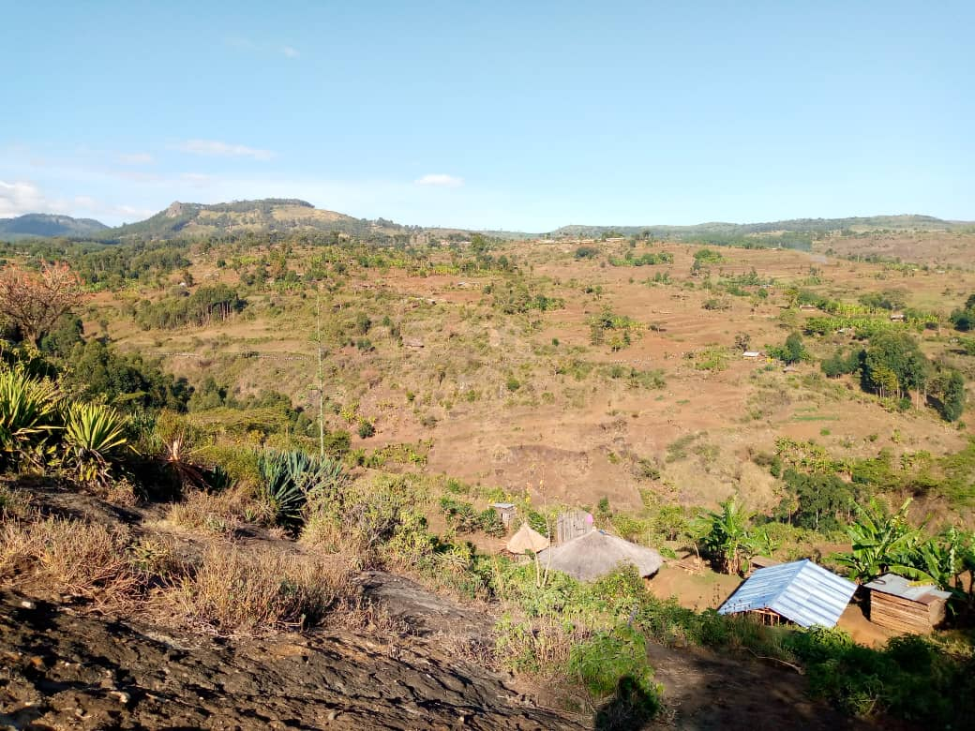

You are working with Sunset Tours and Travel Company Limited as a tour guide. A group of American tourists are planning to visit your country during their summer holiday. They have visited your company website and have booked your company to help them tour certain areas of interest. The company manager is of the view that the tourists should visit the area shown in the photograph. As their guide-to- be, the company manager has instructed you to prepare a written descriptive account informing the visitors of the attractions they will see and activities they will engage in when they come to visit the area identified and the likely challenges they may face.

**Task:**

(a) Draw a landscape sketch of the photograph and on it mark and name the features found in the area shown in the photo. (12 scores)

(b) Describe for the visitors the attractions they will see and the activities they will engage in when they visit the area. Give evidence from the photograph.(5 scores)

(c) What recommendations would you make to the local community to improve the area for tourism? (8 scores)

**SECTION B**

**This section has two parts I and II.**

**Part I**

**Answer one item from this part.**

**Item 3**

The existence of the major relief and drainage features of African continent is scientifically connected to the tectonic processes such as faulting, volcanicity, warping and folding and such features are making Africa an attractive continent to many foreign tourists from Europe Asia and other parts of the world. A University student from Manchester in UK has visited you as a professor in Geology and landform development, seeking for clarity on how any one of the following features was formed and how it benefits the people in the local area as well as it's contribution to the development of Africa as a continent.

**Task:**

Write a speech that will be read to the student from Manchester by your secretary that will satisfy the student to the extent of promising to visit you again for further geographical research.

(25 marks)

**Item 4.**

According to the 2021 Uganda Population Survey, the country’s population was estimated to be 42 million, and growing at a rate of 3 % per year. At this rate, the country’s population is expected to reach 72.4 million people by 2040; representing an annual increase of 1.6 million people per year. Members of your community have different views about this rate of population growth. Some see it as a benefit, while others think it is a danger to the country.

**Support materials:**

Table showing Uganda’s population between 1980 and 2023

|  |  |
| --- | --- |
| Year | Population (in millions) |
| 1980 | 12.6 |
| 1991 | 16.7 |
| 2002 | 24.2 |
| 2014 | 34.6 |
| 2023 | 48.6 |

Adopted: (UBOS, and Trending Economics)

**Task:**

(a) Draw a suitable graph to show the information in the table. ( 10 scores)

(b) Using the information provided in the text and table, write an article of between 250 – 300 to be published in one of the local newspapers that will help you deal with the concerns of the members of your community. (15 marks)

**Part II**

**Answer one item from this part.**

**Item 5.**

.Study the table below showing the climate of station F and answer the questions that follow.

|  |  |  |  |  |  |  |  |  |  |  |  |  |
| --- | --- | --- | --- | --- | --- | --- | --- | --- | --- | --- | --- | --- |
| Month | **J** | **F** | **M** | **A** | **M** | **J** | **J** | **A** | **S** | **O** | **N** | **D** |
| Temp (oC) | 20 | 21 | 22 | 22 | 21 | 20 | 20 | 21 | 22 | 22 | 21 | 20 |
| Rainfall (mm) | 30 | 40 | 128 | 195 | 190 | 40 | 54 | 98 | 130 | 218 | 145 | 37 |

1. Using the graph paper provided, neatly draw a climate graph to portray the above data.

(10scores)

1. Identify the type of climate with a reason. (02 scores)
2. List down any five economic activities that can be carried out in the area where the statistics were taken from. (5scores)
3. From the above table, determine the following;
   1. Annual Range of Temperature. (2scores)
   2. Mean Annual Rainfall. (2scores)
   3. Mean Annual Temperature. (2scores)
   4. The driest month and coolest month (2score)

**Item 6**

90% households in Uganda derive their energy from firewood and charcoal. According to the world bank, the total demand for wood fuel is estimated to have increased by 9.1%between 2015- 2019. This has translated into massive acres of forests and woodlands being cleared for firewood and charcoal leading to climate change. *(source: The new vision Newspaper: February 19th 2023).*

***Task:***

*You have been appointed as a national programme officer for NEMA, write an essay of about 150-250 words on the advices you will make to the ministry of environment to change the trend of the forest cover destruction.* (score 25)